To install Safe sign 3.0.93 versions follow below procedure:

1. Select “ installutil ” file and run,
2. Below window will appear

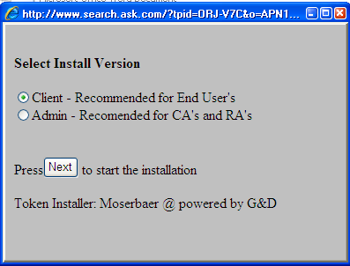

Select option for admin version or client version installation and Press next to start.

It will run and install windows environment necessary information utility,

Below Window will appear

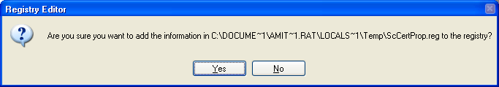

1. Now click on **Yes.**
2. Follow instruction as on screen,
3. After finish utility installation, this will ask to install CCA root certificate, press YES and then install certificate,
4. It will select appropriate installation middleware as per your system, then follow screen instruction and finish installation,
5. Then restart your personal computer and check token under token admin utility,